[](http://www.google.com.eg/imgres?q=girl+smelling&hl=ar&sa=X&biw=1093&bih=477&tbm=isch&prmd=imvns&tbnid=DqIlqC3RN44wVM:&imgrefurl=http://www.skywriting.net/inspirational/poems/the_fragrant_rose.html&docid=G_fo1u_z7yby9M&imgurl=http://www.skywriting.net/images/girl-rose-uk2.jpg&w=384&h=288&ei=bfoaT9uiHcyc-waKpcHACg&zoom=1)  
[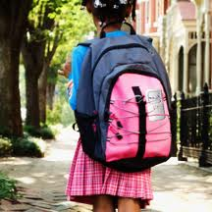](http://www.google.com.eg/imgres?q=kid+wearing&hl=ar&biw=1093&bih=477&tbm=isch&tbnid=ZPklDomUhnZPFM:&imgrefurl=http://www.momlogic.com/2010/03/track_the_kids_with_a_gps.php&docid=cIkrpe8o6qdfoM&imgurl=http://www.momlogic.com/images/kid-wearing-backpack-270-thumb-270x270.jpg&w=270&h=270&ei=pvoaT_qABIij-gasnrG-Cg&zoom=1)[](http://www.google.com.eg/imgres?q=kid+wearing&hl=ar&biw=1093&bih=477&tbm=isch&tbnid=3ylyXEn40SU0qM:&imgrefurl=http://blog.lib.umn.edu/nich0185/myblog/2011/11/should-we-all-listen-to-mozart-music.html&docid=BIoYxBJOd0J4QM&imgurl=http://blog.lib.umn.edu/nich0185/myblog/Kid-wearing-headphones1.jpg&w=300&h=244&ei=pvoaT_qABIij-gasnrG-Cg&zoom=1)[](http://www.google.com.eg/imgres?q=kid+wearing&hl=ar&biw=1093&bih=477&tbm=isch&tbnid=IMubmhd1oKgNjM:&imgrefurl=http://www.123rf.com/photo_5455429_a-portrait-of-a-stylish-indian-kid-wearing-sunglasses-on-a-black-studio-background.html&docid=YhkqMS7BEWh2gM&imgurl=http://us.123rf.com/400wm/400/400/thefinalmiracle/thefinalmiracle0908/thefinalmiracle090800161/5455429-a-portrait-of-a-stylish-indian-kid-wearing-sunglasses-on-a-black-studio-background.jpg&w=1200&h=801&ei=pvoaT_qABIij-gasnrG-Cg&zoom=1)[](http://www.google.com.eg/imgres?q=kid+combing&hl=ar&biw=1093&bih=477&tbm=isch&tbnid=FxRgesyYNc-POM:&imgrefurl=http://www.dreamstime.com/stock-image-girl-combing-hair-image6929151&docid=4UYJg6Hk3ayVjM&imgurl=http://www.dreamstime.com/girl-combing-hair-thumb6929151.jpg&w=370&h=450&ei=sfsaT9LyKs_n-gaKm4kc&zoom=1)[](http://www.google.com.eg/imgres?q=kid+jumping&hl=ar&biw=1093&bih=477&tbm=isch&tbnid=KlhLiEhF3d71SM:&imgrefurl=http://www.featurepics.com/online/Smart-Kid-Jumping-High-Air-1659781.aspx&docid=aRCR9K4_Hi9J9M&imgurl=http://www.featurepics.com/FI/Thumb300/20101003/Smart-Kid-Jumping-High-Air-1659781.jpg&w=299&h=449&ei=d_saT77eIcqr-gb3vJXxCQ&zoom=1) [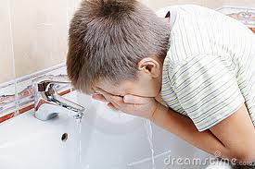](http://www.google.com.eg/imgres?q=kid+washing+face&hl=ar&biw=1093&bih=477&tbm=isch&tbnid=eDVPufWXN930xM:&imgrefurl=http://www.dreamstime.com/stock-image-boy-washing-face-image17351451&docid=JFiv2WRab0SBnM&imgurl=http://www.dreamstime.com/boy-washing-face-thumb17351451.jpg&w=400&h=267&ei=1vsaT7OpF8z_-gab2L32CQ&zoom=1) [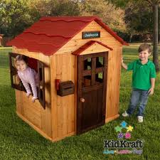](http://www.google.com.eg/imgres?q=kid+close+door&um=1&hl=ar&biw=1093&bih=477&tbm=isch&tbnid=FpVhXhh-TEMi9M:&imgrefurl=http://www.bestpricetoys.com/Outdoor-Playhouse-KidKraft/&docid=dp8ZS9Nj0oxvOM&imgurl=http://www.bestpricetoys.com/images/KidKraft-Outdoor-Playhouse.jpg&w=500&h=500&ei=k_waT4e0GNGE-waW08nRCg&zoom=1)

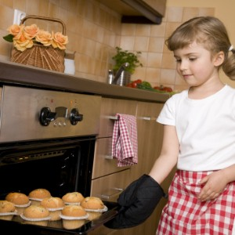[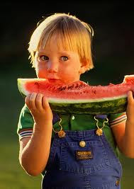](http://www.google.com.eg/imgres?q=kid+throw&um=1&hl=ar&biw=1093&bih=477&tbm=isch&tbnid=jU_KUtH2ifceHM:&imgrefurl=http://www.miketalkssports.blogspot.com/&docid=1BH4z3di6sGwfM&imgurl=http://2.bp.blogspot.com/-rCpUEABEZpc/TacH0Nvh67I/AAAAAAAAAEE/6UYejj4RrZU/s1600/kid%2Bthrow%2B300%2Byard.jpg&w=353&h=500&ei=4_waT92vHI3_-gbM0szHCQ&zoom=1)[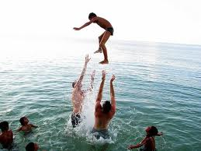](http://www.google.com.eg/imgres?q=kid+throw&um=1&hl=ar&biw=1093&bih=477&tbm=isch&tbnid=0AI1seJ6izSN_M:&imgrefurl=http://www.sethbarnes.com/?filename=throw-them-in-the-deep-end&docid=ScQnfReQgvX63M&imgurl=http://www.sethbarnes.com/blogphotos/sethbarnes/www/Throwing_kid.jpg&w=480&h=360&ei=4_waT92vHI3_-gbM0szHCQ&zoom=1)[](http://www.google.com.eg/imgres?q=kid+throw&um=1&hl=ar&biw=1093&bih=477&tbm=isch&tbnid=sSfi95D30_UR0M:&imgrefurl=http://science.cabot.ac.uk/?p=1037&docid=LshHMKHIfua31M&imgurl=http://science.cabot.ac.uk/wp-content/uploads/2010/11/kids-birthday-party.jpg&w=600&h=399&ei=4_waT92vHI3_-gbM0szHCQ&zoom=1)

[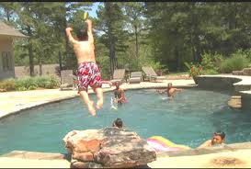](http://www.google.com.eg/imgres?q=kid+throw&um=1&hl=ar&biw=1093&bih=477&tbm=isch&tbnid=kTQpp-6Kf9EoyM:&imgrefurl=http://www.cargodesk.biz/Kids_pool_toys.html&docid=ztakiS3O5g6gnM&imgurl=http://www.cargodesk.biz/Water%2520Dogg%2520Throw.png&w=500&h=338&ei=4_waT92vHI3_-gbM0szHCQ&zoom=1)[](http://www.google.com.eg/imgres?q=kid+throw&um=1&hl=ar&biw=1093&bih=477&tbm=isch&tbnid=EADAZKcAcE8GKM:&imgrefurl=http://www.momsmiami.com/?a=profile&u=2&t=blog&tag=504&docid=Olo-gp8zVgXM7M&imgurl=http://www.momsmiami.com/images/blogs/2795.jpg&w=350&h=263&ei=4_waT92vHI3_-gbM0szHCQ&zoom=1) [](http://www.google.com.eg/imgres?q=kid+throw+trash&um=1&hl=ar&biw=1093&bih=477&tbm=isch&tbnid=kbx5av7kDCsbGM:&imgrefurl=http://ibankcoin.com/flyblog/2010/01/25/the-important-matter-of-not-recycling/&docid=QcDym5mvSgxh-M&imgurl=http://ibankcoin.com/flyblog/files/2010/01/dumbkid.jpg&w=430&h=340&ei=3v0aT7frA8__-gbCluyzCg&zoom=1)[](http://www.google.com.eg/imgres?q=kid+throw+trash&um=1&hl=ar&biw=1093&bih=477&tbm=isch&tbnid=3lyJRHA5p2eBRM:&imgrefurl=http://www.citypages.com/related/to/Healthy+Eating/&docid=YgH1neriTsUyuM&imgurl=http://blogs.citypages.com/food/girl-enjoying-ice-cream.jpg&w=500&h=456&ei=3v0aT7frA8__-gbCluyzCg&zoom=1) [](http://www.google.com.eg/imgres?q=kid+cleaning+room&um=1&hl=ar&biw=1093&bih=477&tbm=isch&tbnid=vYvLeEvx1HnoeM:&imgrefurl=http://villageformoms.blogspot.com/2011/02/what-chores-can-kids-tackle.html&docid=1RfM_oiGEWiBBM&imgurl=http://3.bp.blogspot.com/_PrfMPjjqHIA/TVAvn_6iYGI/AAAAAAAACrk/WbNma5WcZFY/s1600/kids-chores.jpg&w=768&h=734&ei=T_4aT97KI4Gc-waqqoW3Cg&zoom=1)[](http://www.google.com.eg/imgres?q=kid+cleaning+room&um=1&hl=ar&biw=1093&bih=477&tbm=isch&tbnid=6xD5fr51FbG4qM:&imgrefurl=http://themaidssouthct.com/2011/06/28/how-to-get-kids-to-clean-up-after-themselves/&docid=zNJs4vEZpAD0KM&imgurl=http://themaidssouthct.com/wp-content/uploads/2011/06/child-cleaning-room.jpg&w=332&h=448&ei=T_4aT97KI4Gc-waqqoW3Cg&zoom=1)[](http://www.google.com.eg/imgres?q=kid+taking+injection&um=1&hl=ar&biw=1093&bih=477&tbm=isch&tbnid=TygS32Q1qU6RjM:&imgrefurl=http://www.babble.com/CS/blogs/strollerderby/archive/tags/study/default.aspx&docid=hDEn63Mqm0dKtM&imgurl=http://www.babble.com/CS/blogs/strollerderby/2009/01/KidVegetable.jpg&w=300&h=386&ei=k_4aT7jyIZG0-QbN-sG8Cg&zoom=1)[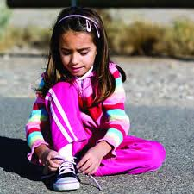](http://www.google.com.eg/imgres?q=kid+wearing+shoe&um=1&hl=ar&biw=1093&bih=477&tbm=isch&tbnid=vgs0ohtvPbatcM:&imgrefurl=http://minisites.contentthatworks.com/health/health_20090416_shoes.html&docid=jFHISSe4fL8eHM&imgurl=http://content.contentthatworks.com/images_articles/2009/health/health_20090416_shoes_banner.jpg&w=300&h=300&ei=8P4aT-mUM4Gg-AbuoITACg&zoom=1)

[](http://www.google.com.eg/imgres?q=kid+throwing+a+paper&um=1&hl=ar&biw=1093&bih=477&tbm=isch&tbnid=g6TxnMqG7OhVVM:&imgrefurl=http://www.shutterstock.co.in/pic-35697961/stock-photo-little-cute-boy-throwing-paper-in-recycle-bin.html&docid=mOMA4RmJ85NzGM&itg=1&imgurl=http://image.shutterstock.com/display_pic_with_logo/386239/386239,1250950231,2/stock-photo-little-cute-boy-throwing-paper-in-recycle-bin-35697961.jpg&w=301&h=470&ei=F_8aT9b4KYeG-wbr7-WfCg&zoom=1)[](http://www.google.com.eg/imgres?q=kid+blowing&um=1&hl=ar&biw=1093&bih=477&tbm=isch&tbnid=8xpcohyY29pp-M:&imgrefurl=http://endless-tales.onsugar.com/date/2010/2/14&docid=EtZTfi4jGxF1mM&imgurl=http://media.onsugar.com/files/2010/02/06/0/434/4341244/0e8bbc577e647666_forever-blowing-bubbles_44631_1_.jpg&w=468&h=300&ei=Q_8aT9TwItCi-gblrvGyCg&zoom=1)

[](http://www.google.com.eg/imgres?q=kid+blowing&um=1&hl=ar&biw=1093&bih=477&tbm=isch&tbnid=nfvj1xdwVNI8jM:&imgrefurl=http://www.parentsconnect.com/parenting-your-kids/kids-health/allergies/&docid=wcOBvxVpTWEZdM&imgurl=http://images2.parentsconnect.com/editorial_images/0/boy-blowing-nose-tissue.jpg%3Fquality%3D0.6%26&w=280&h=280&ei=Q_8aT9TwItCi-gblrvGyCg&zoom=1)

[](http://www.google.com.eg/imgres?q=kid+blowing+balloon&um=1&hl=ar&biw=1093&bih=477&tbm=isch&tbnid=9_2phdQsxHZPIM:&imgrefurl=http://www.dreamstime.com/stock-image-funny-boy-blowing-up-a-yellow-balloon-image14800041&docid=eydQjg99SU9smM&imgurl=http://www.dreamstime.com/funny-boy-blowing-up-a-yellow-balloon-thumb14800041.jpg&w=400&h=402&ei=EgAbT4PJHoOs-gbAiYG9Cg&zoom=1)[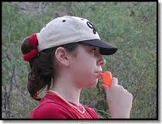](http://www.google.com.eg/imgres?q=kid+whistle&um=1&hl=ar&tbm=isch&tbnid=Kd5tG4mKMJj81M:&imgrefurl=http://starwarmer.org/childrenssurvival.html&docid=fjNNYZJ9CJGovM&imgurl=http://www.equipped.com/GRAPHICS/kid-whistle-sm.jpg&w=262&h=200&ei=fwAbT57gFdCM-wbr69nFCg&zoom=1&iact=hc&vpx=620&vpy=164&dur=823&hovh=160&hovw=209&tx=95&ty=91&sig=105254546760605070925&page=1&tbnh=133&tbnw=144&start=0&ndsp=11&ved=1t:429,r:1,s:0&biw=1093&bih=477)

[](http://www.google.com.eg/imgres?q=muslim+kid&um=1&hl=ar&biw=1093&bih=477&tbm=isch&tbnid=IFBqlW5pPGQZyM:&imgrefurl=http://www.shutterstock.com/pic-48590341/stock-photo-muslim-kid-with-holy-book-koran.html&docid=Kiz5BxB5dm-0PM&imgurl=http://image.shutterstock.com/display_pic_with_logo/386239/386239,1268500485,3/stock-photo-muslim-kid-with-holy-book-koran-48590341.jpg&w=299&h=470&ei=9AAbT6mxNsOd-wad8J3BCg&zoom=1)[](http://www.google.com.eg/imgres?q=muslim+kid&um=1&hl=ar&biw=1093&bih=477&tbm=isch&tbnid=GHeDh0ivSDWaaM:&imgrefurl=http://islamickorner.net/showthread.php/8154-muslim-kids/page15&docid=duXNLIwuaddfMM&imgurl=http://i.istockimg.com/file_thumbview_approve/8198142/2/stock-photo-8198142-muslim-kids-praying.jpg&w=380&h=250&ei=9AAbT6mxNsOd-wad8J3BCg&zoom=1)[](http://www.google.com.eg/imgres?q=muslim+kid&um=1&hl=ar&biw=1093&bih=477&tbm=isch&tbnid=d33r0h9W3jVczM:&imgrefurl=http://www.shutterstock.com/pic-82022119/stock-photo-arabic-muslim-kid-showing-islamic-prayer.html&docid=YrrOhf7LNOZnEM&imgurl=http://image.shutterstock.com/display_pic_with_logo/516343/516343,1312136505,1/stock-photo-arabic-muslim-kid-showing-islamic-prayer-82022119.jpg&w=299&h=470&ei=9AAbT6mxNsOd-wad8J3BCg&zoom=1)[](http://www.google.com.eg/imgres?q=kid+brushing+close+up&um=1&hl=ar&biw=1093&bih=477&tbm=isch&tbnid=u9V6qoS7TNgIHM:&imgrefurl=http://www.guardian.co.uk/society/2011/jan/30/tooth-decay-children-dental-health-sweets&docid=vYwHllNu1g0-eM&imgurl=http://static.guim.co.uk/sys-images/Observer/Columnist/Columnists/2011/1/29/1296296490076/Young-boy-brushing-his-te-007.jpg&w=460&h=276&ei=OQIbT4SlKs3o-ga62qWuCg&zoom=1)[](http://www.google.com.eg/imgres?q=kid+cutting+paper&um=1&hl=ar&biw=1093&bih=477&tbm=isch&tbnid=l3ZREQxp5p0tkM:&imgrefurl=http://www.superstock.com/stock-photos-images/4065-8168&docid=PpnfIVzIZZvZ6M&imgurl=http://wwwdelivery.superstock.com/WI/223/4065/PreviewComp/SuperStock_4065-8168.jpg&w=233&h=350&ei=uAIbT-i2A43_-gbM0szHCQ&zoom=1)[](http://www.google.com.eg/imgres?q=kid+cutting+paper&um=1&hl=ar&biw=1093&bih=477&tbm=isch&tbnid=GD2XEysCvysaBM:&imgrefurl=http://humaurtumgroup.blogspot.com/2011/06/beautiful-inspiring-story-mothers-love.html&docid=x2zEUXriORhBxM&imgurl=http://2.bp.blogspot.com/-xqTtlSuyl_k/Tet1WTW4-DI/AAAAAAAAAG0/xsaSWv0xzAU/s1600/mother-and-child-1a.jpg&w=600&h=400&ei=uAIbT-i2A43_-gbM0szHCQ&zoom=1)[](http://www.google.com.eg/imgres?q=kid+drawing&um=1&hl=ar&biw=1093&bih=477&tbm=isch&tbnid=7j7k9NERAF_ahM:&imgrefurl=http://maketecheasier.com/5-simple-drawing-applications-for-mac/2009/05/26&docid=I6VEaq1PZx2snM&imgurl=http://images.maketecheasier.com/2009/05/kid-drawing.jpg&w=250&h=166&ei=fgMbT7DnI8aA-wbS-MCXBA&zoom=1)[](http://www.google.com.eg/imgres?q=kid+making+sandwich&um=1&hl=ar&biw=1093&bih=477&tbm=isch&tbnid=NEuB1BkJYaPMNM:&imgrefurl=http://www.esquire.com/features/holiday-activities-for-kids-1209&docid=1IpCU043dbqsVM&imgurl=http://www.esquire.com/cm/esquire/images/boy-making-sandwich-lg-74179902.jpg&w=300&h=400&ei=BwQbT9WCPNDo-ga2waH4CQ&zoom=1)[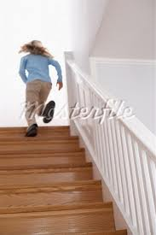](http://www.google.com.eg/imgres?q=kid+stairs&um=1&hl=ar&biw=1093&bih=477&tbm=isch&tbnid=9zZ4JthUjUvbDM:&imgrefurl=http://www.masterfile.com/stock-photography/image/700-00547176/Girl-Running-Up-Staircase&docid=SZQrfK1KdOW6RM&imgurl=http://image1.masterfile.com/em_w/00/54/71/700-00547176w.jpg&w=367&h=550&ei=UwQbT67PM9Gq-gaQ2KiqCg&zoom=1)[](http://www.google.com.eg/imgres?q=kid+stairs&um=1&hl=ar&biw=1093&bih=477&tbm=isch&tbnid=NNKVxwdBDIqr3M:&imgrefurl=http://www.masterfile.com/stock-photography/image/700-00547179/Girl-Looking-Down-Staircase&docid=jxGgOOC5THSC5M&imgurl=http://image1.masterfile.com/em_w/00/54/71/700-00547179w.jpg&w=367&h=550&ei=UwQbT67PM9Gq-gaQ2KiqCg&zoom=1)[](http://www.google.com.eg/imgres?q=kid+falling+stairs&um=1&hl=ar&biw=1093&bih=477&tbm=isch&tbnid=s07fH0XTMFUY1M:&imgrefurl=http://www.sodahead.com/fun/do-you-take-the-elevator-or-stairs/question-2038323/&docid=7gUmw1dso2w9xM&imgurl=http://door32.files.wordpress.com/2010/06/falling-down-stairs.jpg&w=233&h=350&ei=qgQbT4ayJsKc-wb6k6nPCg&zoom=1)[](http://www.google.com.eg/imgres?q=kid+falling+bike&um=1&hl=ar&biw=1093&bih=477&tbm=isch&tbnid=vqZbikBAtgISbM:&imgrefurl=http://monkeysforhelping.blogspot.com/2006/01/dark-side-of-knitting.html&docid=B-TAY2rtEtm-sM&imgurl=http://i12.photobucket.com/albums/a239/djrecon83/46fc91711_fahrradunfall_bulletinboa.jpg&w=450&h=325&ei=zAQbT7-oLpGG-wbv04W-DQ&zoom=1)[](http://www.google.com.eg/imgres?q=kid+falling+bike&um=1&hl=ar&biw=1093&bih=477&tbm=isch&tbnid=FLbam-hiD6oo5M:&imgrefurl=http://www.shutterstock.com/pic-74752519/stock-photo-boy-hurt-after-falling-off-his-bicycle.html&docid=2jMppqF1JZ12fM&imgurl=http://image.shutterstock.com/display_pic_with_logo/11733/11733,1302150456,1/stock-photo-boy-hurt-after-falling-off-his-bicycle-74752519.jpg&w=300&h=470&ei=zAQbT7-oLpGG-wbv04W-DQ&zoom=1)[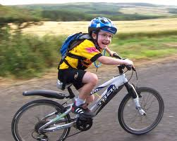](http://www.google.com.eg/imgres?q=kid+falling+bike&um=1&hl=ar&biw=1093&bih=477&tbm=isch&tbnid=tO9pnT-yOcTaBM:&imgrefurl=http://www.bikehub.co.uk/featured-articles/safe-cycling-for-kids-but-not-wrapped-in-cotton-wool/&docid=zVfar5h65b9rPM&imgurl=http://www.bikehub.co.uk/wp-content/uploads/2011/03/100_1800.jpg&w=1682&h=1344&ei=zAQbT7-oLpGG-wbv04W-DQ&zoom=1)[](http://www.google.com.eg/imgres?q=kid+clap&um=1&hl=ar&biw=1093&bih=477&tbm=isch&tbnid=7CPq4CWlfINe5M:&imgrefurl=http://www.superstock.com/stock-photos-images/1647R-80199&docid=LPzrNRqdwXcdIM&imgurl=http://wwwdelivery.superstock.com/WI/223/1647/PreviewComp/SuperStock_1647R-80199.jpg&w=280&h=350&ei=GwUbT8feDML_-gbMvuH4CQ&zoom=1)[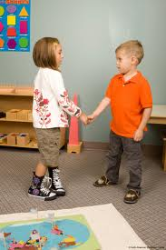](http://www.google.com.eg/imgres?q=kid+shaking+hand&um=1&hl=ar&biw=1093&bih=477&tbm=isch&tbnid=xSPfkKb-VPrptM:&imgrefurl=http://montessoritraining.blogspot.com/2010_09_01_archive.html&docid=n1ZEX4bXUnQOqM&imgurl=http://2.bp.blogspot.com/_1RIweY_B6oU/TIAeB6_8LaI/AAAAAAAAACE/e2oofctosT8/s1600/kids%2Bshaking%2Bhands.jpg&w=1067&h=1600&ei=hQUbT6GyF82e-walndyhCg&zoom=1)[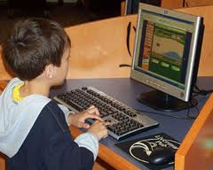](http://www.google.com.eg/imgres?q=kid+usingcomputer&um=1&hl=ar&biw=1093&bih=477&tbm=isch&tbnid=dLrTe62W-uTxsM:&imgrefurl=http://www.vtmagazine.vt.edu/winter06/ontheweb.html&docid=TEJm9Bw50WTm6M&imgurl=http://www.vtmagazine.vt.edu/winter06/images/computerkid.jpg&w=300&h=240&ei=AQYbT5uOJoHG-QbOusGsCg&zoom=1)[](http://www.google.com.eg/imgres?q=kid+usingcomputer&um=1&hl=ar&biw=1093&bih=477&tbm=isch&tbnid=OyCfhZyRsnmLTM:&imgrefurl=http://cyberologyconsultants.com/education/internet-safety-related/parent-awareness&docid=wZF5g22oPq_qFM&imgurl=http://cyberologyconsultants.com/files/2011/05/Child_Computer.jpg&w=640&h=522&ei=AQYbT5uOJoHG-QbOusGsCg&zoom=1)[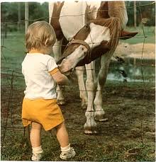](http://www.google.com.eg/imgres?q=kid+feeding+a+horse&um=1&hl=ar&biw=1093&bih=477&tbm=isch&tbnid=bRzZODoj4vdt8M:&imgrefurl=http://shakespearessister.blogspot.com/2010/07/daily-dose-o-cute_27.html&docid=awLD5EoSaYWKcM&imgurl=http://img.photobucket.com/albums/v642/shakespeares_sister/shakes5/lissandtodie.png&w=350&h=364&ei=dgYbT-vxIMeE-waly5z1CQ&zoom=1)[](http://www.google.com.eg/imgres?q=kid+smiling&um=1&hl=ar&biw=1093&bih=477&tbm=isch&tbnid=ZkkJgDzOg8LRxM:&imgrefurl=http://www.familydentistedmonton.com/dentist-terwillegar-riverbend/family-dental&docid=DrJkmtCXFWKu3M&imgurl=http://www.familydentistedmonton.com/wp-content/uploads/2010/12/bigstock_Laughing_Baby_1491039.jpg&w=900&h=721&ei=IgcbT4KgEs-f-waI6ZXACg&zoom=1)[](http://www.google.com.eg/imgres?q=kid+crying&um=1&hl=ar&biw=1093&bih=477&tbm=isch&tbnid=pFMtduGxGGxx-M:&imgrefurl=http://blogs.seattleweekly.com/dailyweekly/2010/08/jose_lopez_is_the_worst_hitter.php&docid=cV0MCZCLGFr0hM&imgurl=http://blogs.seattleweekly.com/dailyweekly/kid%2520crying.jpg&w=500&h=338&ei=RAcbT7nuMsH0-gb3lMS4Cg&zoom=1)

[](http://www.google.com.eg/imgres?q=kid+playing+tennis&um=1&hl=ar&biw=1093&bih=477&tbm=isch&tbnid=m4vz59wrXzDqdM:&imgrefurl=http://www.superstock.com/stock-photos-images/1848-90848&docid=RroUBdZFvBQ57M&imgurl=http://wwwdelivery.superstock.com/WI/223/1848/PreviewComp/SuperStock_1848-90848.jpg&w=350&h=250&ei=nQcbT_mdAsak-gahiY3ACg&zoom=1)[](http://www.google.com.eg/imgres?q=kid+washing+hands&um=1&hl=ar&biw=1093&bih=477&tbm=isch&tbnid=LxvPBQux9V0f8M:&imgrefurl=http://www.sheknows.com/parenting/articles/816255/routines-to-help-special-needs-kids-thrive-1&docid=nzT40nEiFuQBIM&imgurl=http://cdn.sheknows.com/articles/2010/07/girl-washing-hands.jpg&w=600&h=398&ei=GwobT_2KCo6k-gbsnLDICg&zoom=1)[](http://www.google.com.eg/imgres?q=kid+washing+face&um=1&hl=ar&biw=1093&bih=477&tbm=isch&tbnid=sFjZCc4oe4jd8M:&imgrefurl=http://www.joeschedule.com/&docid=cRtTDMg2lx18PM&imgurl=http://www.joeschedule.com/cgi/ngfop/pics/pic_01/DSCF0023.JPG&w=428&h=524&ei=KAsbT_DkD8qe-QbZirW9Cg&zoom=1)[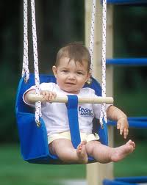](http://www.google.com.eg/imgres?q=kid+swing&um=1&hl=ar&biw=1093&bih=477&tbm=isch&tbnid=CUDX8S0yveZPZM:&imgrefurl=http://www.cedarworks.com/component/revelry/2&docid=LE_L06j7KaxnyM&imgurl=http://media.cedarworks.com/themes/breathingroom/img/components/600/RL_kid_swing.jpg&w=478&h=600&ei=VAsbT422H8Lm-gbt8oXMCg&zoom=1)[](http://www.google.com.eg/imgres?q=kid+eating+apple&um=1&hl=ar&biw=1093&bih=477&tbm=isch&tbnid=Akndrvhnuz2dvM:&imgrefurl=http://www.sodahead.com/fun/do-you-like-candied-apples/question-1762991/comment-57170075/&docid=NeyPI_YLQ5wOWM&imgurl=http://www.ecomom.com/blog/wp-content/gallery/kids/kid-eating-apple.jpg&w=344&h=349&ei=mAsbT9X7EIe6-AagvOmyCg&zoom=1)[](http://www.google.com.eg/imgres?q=kid+reading&um=1&hl=ar&biw=1093&bih=477&tbm=isch&tbnid=QxxmgcPJLj3JaM:&imgrefurl=http://www.learnandplaytoday.com/tag/kids-books/&docid=8BQ077JzNNJDWM&imgurl=http://www.learnandplaytoday.com/wp-content/uploads/2011/09/Kid-Reading-Story-Book.jpg&w=260&h=260&ei=ygsbT7KXPMKe-wb9nvyjCg&zoom=1)[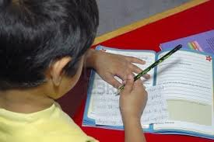](http://www.google.com.eg/imgres?q=kid+writing&um=1&hl=ar&biw=1093&bih=477&tbm=isch&tbnid=cJxWN5MsOE2MyM:&imgrefurl=http://www.123rf.com/photo_603104_kid-writing-his-homework-on-a-week-day.html&docid=swT_qdc5dibssM&imgurl=http://us.123rf.com/400wm/400/400/dnivrab/dnivrab0611/dnivrab061100065/603104-kid-writing-his-homework-on-a-week-day.jpg&w=1200&h=798&ei=7wsbT7aYLoj1-gaC5fXQCg&zoom=1)

[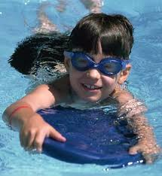](http://www.google.com.eg/imgres?q=kid+swimming+lesson&um=1&hl=ar&biw=1093&bih=477&tbm=isch&tbnid=3WfCIrleoREGCM:&imgrefurl=http://www.weber.edu/aquatics/dropdowns/classes.html&docid=rN0l9YLDaZhjcM&imgurl=http://www.weber.edu/WSUImages/aquatics/swim%2520lesson1.jpg&w=321&h=350&ei=fwwbT_HQAs-c-wazzJDxCQ&zoom=1)[](http://www.google.com.eg/imgres?q=kid+karate+lesson&um=1&hl=ar&biw=1093&bih=477&tbm=isch&tbnid=ISZfefhMvWo6eM:&imgrefurl=http://waldorfmartialarts.com/preschool-karate/&docid=L08T6MlcglV2rM&imgurl=http://waldorfmartialarts.com/wp-content/uploads/2009/07/kids-karate-ages-4-5-6-b.jpg&w=300&h=300&ei=qwwbT6CdI82E-watvYjRCg&zoom=1)[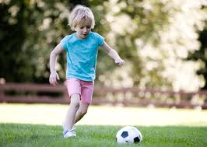](http://www.google.com.eg/imgres?q=kid+kicking+ball&um=1&hl=ar&biw=1093&bih=477&tbm=isch&tbnid=VsC70rKqPGVi3M:&imgrefurl=http://www.babycenter.com/how-to-kick-gallery&docid=zcJSEu7X1COkJM&imgurl=http://assets.babycenter.com/ims/2009/05may/kicking1_1.gif&w=424&h=302&ei=HQ0bT-bHNNGq-AbInaXBCg&zoom=1)[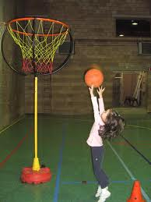](http://www.google.com.eg/imgres?q=kid+basketball&um=1&hl=ar&biw=1093&bih=477&tbm=isch&tbnid=JAp2LdhhJSmubM:&imgrefurl=http://www.clker.com/clipart-40958.html&docid=34Z97W3N7ucgQM&imgurl=http://www.clker.com/cliparts/1/6/c/9/12580189111851496427bild0709%2520(2)-hi.png&w=450&h=600&ei=Og0bT7bkFIef-wa36NnNCg&zoom=1)[](http://www.google.com.eg/imgres?q=kid+wearing+jacket&um=1&hl=ar&biw=1093&bih=477&tbm=isch&tbnid=N_oIGLrGRq_CiM:&imgrefurl=http://www.clipartheaven.com/show/clipart/kids_stuff/images_(g_-_z)/girl_wearing_jacket-gif.html&docid=rQnWWGTQHoUABM&imgurl=http://www.clipartheaven.com/clipart/kids_stuff/images_(g_-_z)/girl_wearing_jacket.gif&w=333&h=588&ei=fw0bT4mTI4WM-wbJysiiCg&zoom=1)[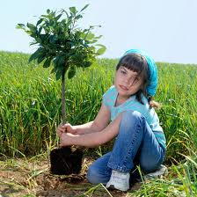](http://www.google.com.eg/imgres?q=kid+planting&um=1&hl=ar&biw=1093&bih=477&tbm=isch&tbnid=8JmmCd4nchz7qM:&imgrefurl=http://www.infobarrel.com/5_Fun_Earth_Day_Activities_for_Kids_of_All_Ages&docid=sJ0kpxQyn4QejM&imgurl=http://www.infobarrel.com/media/image/11927.jpg&w=398&h=398&ei=4A0bT4jJJIe6-AagvOmyCg&zoom=1)[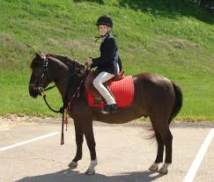](http://www.google.com.eg/imgres?q=kid+riding+horse&um=1&hl=ar&biw=1093&bih=477&tbm=isch&tbnid=BY0RJFGhaywvJM:&imgrefurl=http://blythdale.tripod.com/coventryequestriancenter/id58.html&docid=rm_KCNJ60NVnyM&imgurl=http://blythdale.tripod.com/sitebuildercontent/sitebuilderpictures/coventry_kid_in_parade.jpg&w=1279&h=1091&ei=Yg4bT-OCB4j1-gaC5fXQCg&zoom=1)[](http://www.google.com.eg/imgres?q=kid+drinking+juice&um=1&hl=ar&biw=1093&bih=477&tbm=isch&tbnid=RmvRdFiAxm8I8M:&imgrefurl=http://www.momlogic.com/2009/11/nutrition_fruit_juice.php&docid=TCGUxTFfBnLuyM&imgurl=http://www.momlogic.com/images/kid-drinking-juice-pm-thumb-270x270.jpg&w=270&h=270&ei=jw4bT7bcKYWc-wawgN3vBQ&zoom=1)

[](http://www.google.com.eg/imgres?q=kid+sleeping&um=1&hl=ar&biw=1093&bih=477&tbm=isch&tbnid=t0FGisMdbyJc9M:&imgrefurl=http://storycube.blogspot.com/2011/10/ideal-sleep-duration-for-kids.html&docid=m_To6SXGsG_ntM&imgurl=http://www.kansasaap.org/wordpress/wp-content/uploads/2011/01/kid-sleeping.jpg&w=397&h=223&ei=wg4bT-zcMtD1-gbAi-GxCg&zoom=1)

[](http://www.google.com.eg/imgres?q=kid+catching&um=1&hl=ar&biw=1093&bih=477&tbm=isch&tbnid=o_LaJZYIGgf02M:&imgrefurl=http://flafin.blogspot.com/2008_06_01_archive.html&docid=6tLhiDGbJRoe2M&imgurl=http://www.inshorefishingadventures.com/Jessie%2520and%2520Shark%2520rs.jpg&w=600&h=451&ei=DA8bT8z2J4-h-QaYxtn3CQ&zoom=1)[](http://www.google.com.eg/imgres?q=kid+holding+umbrella&um=1&hl=ar&biw=1093&bih=477&tbm=isch&tbnid=Ns2lsQe8YF31nM:&imgrefurl=http://www.123rf.com/photo_6364184_kid-girl-with-umbrella-drawing.html&docid=KIxU7H8eBi8EUM&imgurl=http://us.cdn4.123rf.com/168nwm/mirage3/mirage31106/mirage3110600012/9659598-large-childlike-cartoon-character-little-girl-with-a-big-smile-holding-an-umbrella-and-playing-in-th.jpg&w=123&h=168&ei=_g8bT7ylBYug-watzITMCg&zoom=1)[](http://www.google.com.eg/imgres?q=kid+kite&um=1&hl=ar&biw=1093&bih=477&tbm=isch&tbnid=VcHxkDV91VhFdM:&imgrefurl=http://www.mathsmith.com/letsgoflyakite.htm&docid=laHsmDgppojmmM&imgurl=http://images.bimedia.net/images/kite%2Bkid%2Bsmaller.jpg&w=395&h=507&ei=RREbT87PBsOq-AaSlPWpCg&zoom=1)[](http://www.google.com.eg/imgres?q=kid+eating+chips&um=1&hl=ar&biw=1093&bih=477&tbm=isch&tbnid=Q7Dpt-xaLrVp6M:&imgrefurl=http://www.bbc.co.uk/blogs/food/2011/05/fast-food-baby-feeding-the-nex.shtml&docid=rnKy0cPJP4_h5M&imgurl=http://www.bbc.co.uk/blogs/food/food/kidchips.jpg&w=413&h=300&ei=7BEbT9PcK4Ps-ga63pW6Cg&zoom=1)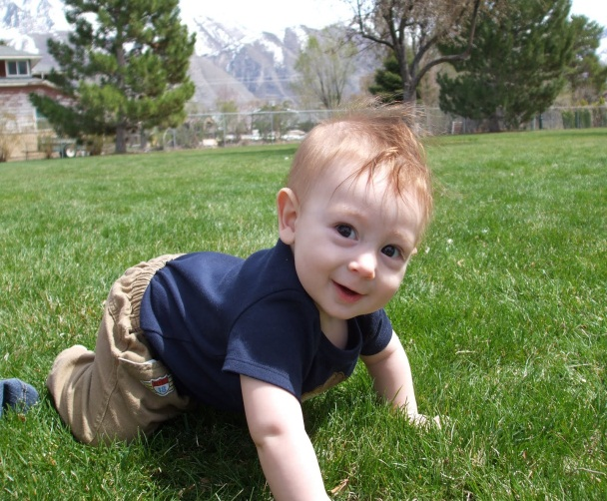

[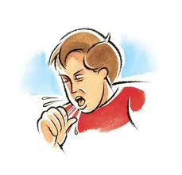](http://www.google.com.eg/imgres?q=kid+coughing&hl=ar&sa=X&biw=1093&bih=477&tbm=isch&prmd=imvns&tbnid=W0-STNZlJtA4tM:&imgrefurl=http://hk0228.edublogs.org/&docid=mNhY5-7EL-4AFM&imgurl=http://professionalmedical.files.wordpress.com/2009/10/coughing1.jpg&w=486&h=469&ei=_xUbT7HTBc2D-wbj2fWjCg&zoom=1)[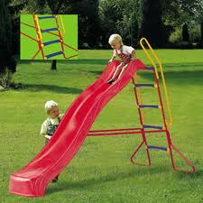](http://www.google.com.eg/imgres?q=kid+sliding&hl=ar&biw=1093&bih=477&tbm=isch&tbnid=hb0qQ6mH3H3bBM:&imgrefurl=http://www.jacksons-camping.co.uk/kidstuff/seesaws.htm&docid=gq2OnsV5qZBh2M&imgurl=http://www.jacksons-camping.co.uk/kidstuff/images/wave-slide.jpg&w=290&h=290&ei=bRYbT6zKHMqd-waL9cDLCg&zoom=1)[](http://www.google.com.eg/imgres?q=kid+talking&hl=ar&biw=1093&bih=477&tbm=isch&tbnid=qQoti-qDjx7gHM:&imgrefurl=http://www.dreamstime.com/royalty-free-stock-photo-cute-kid-talking-on-a-cell-phone-image1057195&docid=T9HyGfxMAO9AaM&imgurl=http://www.dreamstime.com/cute-kid-talking-on-a-cell-phone-thumb1057195.jpg&w=298&h=450&ei=9hYbT6bMOJDt-gav5LivCg&zoom=1)[](http://www.google.com.eg/imgres?q=kid+listening&hl=ar&biw=1093&bih=477&tbm=isch&tbnid=fvLZs9zMfG0G4M:&imgrefurl=http://www.singleapproachablegirl.com/2010/06/im-listening/&docid=2ykFgJCqudj22M&imgurl=http://www.singleapproachablegirl.com/wp-content/uploads/2010/06/listening-kid.jpg&w=849&h=566&ei=bxcbT-7cMIWM-wbJysiiCg&zoom=1)[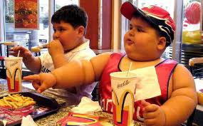](http://www.google.com.eg/imgres?q=kid+listening&hl=ar&biw=1093&bih=477&tbm=isch&tbnid=El0EowhVvxKguM:&imgrefurl=http://joshuajgreene.com/blog/2007/01/&docid=3MADUjeVarGDtM&imgurl=http://joshuajgreene.com/blog/wp-content/uploads/2007/01/mcdonaldscsr.jpg&w=496&h=308&ei=bxcbT-7cMIWM-wbJysiiCg&zoom=1)[](http://www.google.com.eg/imgres?q=kid+listening&hl=ar&biw=1093&bih=477&tbm=isch&tbnid=mhTmVEtyfV9LbM:&imgrefurl=http://www.superstock.com/stock-photos-images/4128R-5563&docid=-oKKAoc3tyhBnM&imgurl=http://wwwdelivery.superstock.com/WI/223/4128/PreviewComp/SuperStock_4128R-5563.jpg&w=350&h=349&ei=bxcbT-7cMIWM-wbJysiiCg&zoom=1)[](http://www.google.com.eg/imgres?q=kid+watching+t.v&hl=ar&biw=1093&bih=477&tbm=isch&tbnid=WnTHkM8mDMhfCM:&imgrefurl=http://imo.thejakartapost.com/fajarprasetya/2011/04/16/how-does-tv-influence-your-life/&docid=GmlJh5juXyiVKM&imgurl=http://imo.thejakartapost.com/fajarprasetya/files/2011/04/kid-watching-tv.gif&w=200&h=220&ei=txgbT732Osie-Qap44DMCg&zoom=1)[](http://www.google.com.eg/imgres?q=kid+playing+puzzle&hl=ar&biw=1093&bih=477&tbm=isch&tbnid=T1ggzwd9IpNLeM:&imgrefurl=http://www.clipartclipart.com/pages/100421-144646-112057.html&docid=WvujyzFakmpbAM&imgurl=http://www.clipartclipart.com/_images_300/Child_constructing_a_puzzle_100421-144646-112057.jpg&w=267&h=300&ei=5xgbT5vRIZCe-Qa3lcGjCg&zoom=1)[](http://www.google.com.eg/imgres?q=kid+playing+guitar&hl=ar&biw=1093&bih=477&tbm=isch&tbnid=ADTAiy4f9q0ZDM:&imgrefurl=http://www.intigalaxy.com/lessons/&docid=hJcRScRQlufGaM&imgurl=http://www.intigalaxy.com/images/kid.png&w=451&h=337&ei=SRkbT4juN8b1-gbV2ujDCg&zoom=1)[](http://www.google.com.eg/imgres?q=kid+climbing&hl=ar&biw=1093&bih=477&tbm=isch&tbnid=KsRfqYP3iEJ_2M:&imgrefurl=http://www.istockphoto.com/stock-photo-12986278-kid-climbing-a-tree.php&docid=N_PcYG0_9yFwjM&imgurl=http://i.istockimg.com/file_thumbview_approve/12986278/2/stock-photo-12986278-kid-climbing-a-tree.jpg&w=380&h=340&ei=rhkbT-73NJG6-AbXt6DECg&zoom=1)[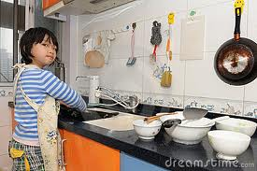](http://www.google.com.eg/imgres?q=kid+washing&hl=ar&biw=1093&bih=477&tbm=isch&tbnid=S-fhAr58B2kS8M:&imgrefurl=http://www.dreamstime.com/stock-fotografie-de-aziatische-schotels-van-de-jong-geitjewas-image17387232&docid=HVij6geNpfUdyM&imgurl=http://www.dreamstime.com/asian-kid-washing-dishes-thumb17387232.jpg&w=400&h=267&ei=Wx4bT-znI4ij-gasnrG-Cg&zoom=1)[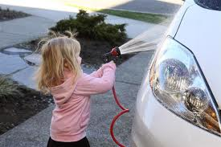](http://www.google.com.eg/imgres?q=kid+washing&hl=ar&biw=1093&bih=477&tbm=isch&tbnid=kGqvC3nbks7VdM:&imgrefurl=http://momstart.com/2011/02/washing-the-car-in-40-degree-weather-wordless-wednesday/&docid=GGo5KlS53cqpMM&imgurl=http://momstart.com/wp-content/uploads/2011/02/kid-washing-car.jpg&w=1024&h=683&ei=Wx4bT-znI4ij-gasnrG-Cg&zoom=1)[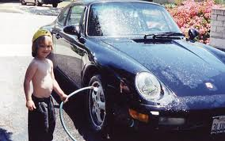](http://www.google.com.eg/imgres?q=kid+washing&hl=ar&biw=1093&bih=477&tbm=isch&tbnid=nRjUhIl2kE5RpM:&imgrefurl=http://www.motortrend.com/features/consumer/112_0810_dan_meis_celeb_drive/photo_03.html&docid=7HtGhGFDEQLbvM&imgurl=http://image.motortrend.com/f/10963109%2Bw786%2Bar1/112_0810_02z%2Bdan_meis_celeb_drive%2Bkid_washing_porsche.jpg&w=786&h=492&ei=Wx4bT-znI4ij-gasnrG-Cg&zoom=1)[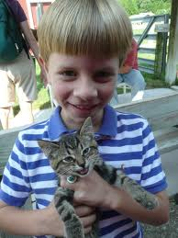](http://www.google.com.eg/imgres?q=kid+feeding+a&hl=ar&biw=1093&bih=477&tbm=isch&tbnid=3sZzi7JZqj20KM:&imgrefurl=http://northerngirlsouthernsoul.blogspot.com/2010_08_01_archive.html&docid=QbtzAuq9MAXpAM&imgurl=http://4.bp.blogspot.com/_A3pUsRlHOIs/TGS4QtOj3oI/AAAAAAAABQk/-HBR1Grd5tI/s1600/cottage%2Bart%2Bday%2B031.JPG&w=1200&h=1600&ei=ICAbT7G-L82p-gaz3snGDQ&zoom=1)[](http://www.google.com.eg/imgres?q=kid+feeding+a&hl=ar&biw=1093&bih=477&tbm=isch&tbnid=UxnCO3HEgTJg1M:&imgrefurl=http://www.babycenter.com/baby-solid-feeding-basics&docid=1UK4GegETbjJ5M&imgurl=http://assets.babycenter.com/ims/2008/07july/july08_firstbite_hopeitsme.jpg&w=424&h=302&ei=ICAbT7G-L82p-gaz3snGDQ&zoom=1)[](http://www.google.com.eg/imgres?q=kid+planting&start=11&hl=ar&biw=1311&bih=572&tbm=isch&tbnid=1fu6XN8pMySCqM:&imgrefurl=http://www.allfreelogo.com/rf-vector/9229730-save-our-green-planet--boy-planting-tree-vector.html&docid=-QF5e9D7STwYvM&imgurl=http://www.allfreelogo.com/images/vector-thumb/save-our-green-planet--boy-planting-tree-prev124144702760O0Ga.jpg&w=300&h=210&ei=viEbT_WqLcmE-wbywPmuCg&zoom=1)[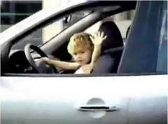](http://www.google.com.eg/imgres?q=kid+riding+car&hl=ar&biw=1311&bih=572&tbm=isch&tbnid=mFOubga_vSSMpM:&imgrefurl=http://www.vehiclespoint.com.au/latest-news.html?start=1050&docid=BX5wSsavGkqo0M&imgurl=http://images.thetruthaboutcars.com/2011/09/kid-driving-car-300x222.jpg&w=300&h=222&ei=PyIbT8ibMor1-gbovuXxCQ&zoom=1)