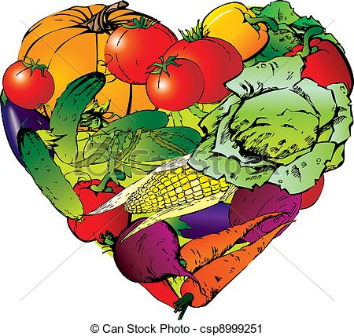

**الخضروات**

|  |  |  |  |
| --- | --- | --- | --- |
| C:\Users\hp\Desktop\tomato-vector-red-fruit_17-208155620.jpg | C:\Users\hp\Desktop\vegetables_18_115480.jpg | C:\Users\hp\Desktop\6ad4af53.jpg | C:\Users\hp\Desktop\b.gif |
| ......................... | ............................ | ........................... | ........................... |

|  |  |  |  |
| --- | --- | --- | --- |
| C:\Users\hp\Desktop\images.jpg | C:\Users\hp\Desktop\images.jpg | C:\Users\hp\Desktop\2453onion__walla_walla_early_2.jpg | C:\Users\hp\Desktop\Pomme_de_terre.jpg |
| ......................... | ........................... | ............................. | ........................... |

|  |  |  |  |
| --- | --- | --- | --- |
| C:\Users\hp\Desktop\url.jpg | C:\Users\hp\Desktop\url.jpg | C:\Users\hp\Desktop\226657_e.jpg | C:\Users\hp\Desktop\images.jpg |
| .......................... | ............................ | .......................... | ......................... |