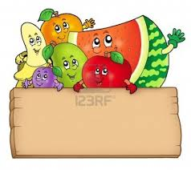

**الغلال**

|  |  |  |  |  |
| --- | --- | --- | --- | --- |
| **C:\Users\hp\Desktop\fruits\imgres.png** | **C:\Users\hp\Desktop\fruits\images.jpg** | **C:\Users\hp\Desktop\fruits\aTea9g6T4.jpeg** | **C:\Users\hp\Desktop\fruits\url.jpg** | **C:\Users\hp\Desktop\fruits\pomegranate-wedge.jpg** |
| **.............** | **..............** | **...............** | **.............** | **..................** |

|  |  |  |  |  |
| --- | --- | --- | --- | --- |
| **C:\Users\hp\Desktop\fruits\can-stock-photo_csp8262900.jpg** | **C:\Users\hp\Desktop\fruits\images.jpg** | **C:\Users\hp\Desktop\fruits\url.jpg** | **C:\Users\hp\Desktop\fruits\images.jpg** | **C:\Users\hp\Desktop\fruits\images.jpg** |
| **.............** | **...............** | **.............** | **..............** | **................** |

|  |  |  |  |  |
| --- | --- | --- | --- | --- |
| **C:\Users\hp\Desktop\fruits\url.jpg** | **C:\Users\hp\Desktop\fruits\url.jpg** | **C:\Users\hp\Desktop\fruits\images.jpg** | **C:\Users\hp\Desktop\fruits\url.jpg** | **C:\Users\hp\Desktop\fruits\images.jpg** |
| **.............** | **..............** | **..............** | **..............** | **................** |