Ministère de l’éducation  Commissariat régional de Ben Arous  Circonscription de Boumhel/Mornag  Ecole primaire ……………………..  Mars 2013 | Examen trimestriel N° 2  Epreuve :  Production Ecrite  Durée de l’épreuve :  40 minutes | Année scolaire :  2012 / 2013  Nom et Prénom :  ……………………………………………………………  Classe : 5ème ……  Numéro du registre:……...
Regarde les images.
Raconte la suite de l’histoire que tu as entendue en introduisant un dialogue d’au moins quatre répliques et imagine la fin.
Ne rien écrire ici
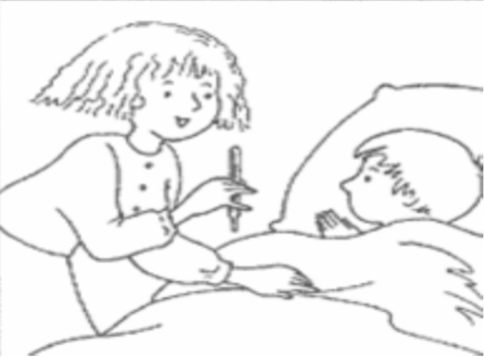 | ………………………………………………………………………………………………………………………………………………  ………………………………………………………………………………………………………………………………………………  ………………………………………………………………………………………………………………………………………………  ………………………………………………………………………………………………………………………………………………  ………………………………………………………………………………………………………………………………………………  ………………………………………………………………………………………………………………………………………………  ………………………………………………………………………………………………………………………………………………  ………………………………………………………………………………………………………………………………………………  ………………………………………………………………………………………………………………………………………………  ………………………………………………………………………………………………………………………………………………  ………………………………………………………………………………………………………………………………………………  ………………………………………………………………………………………………………………………………………………  ………………………………………………………………………………………………………………………………………………  ………………………………………………………………………………………………………………………………………………  ………………………………………………………………………………………………………………………………………………  ………………………………………………………………………………………………………………………………………………  ………………………………………………………………………………………………………………………………………………  ……………………………………………………………………………………………………………………………………………… | C1
 |  | C2
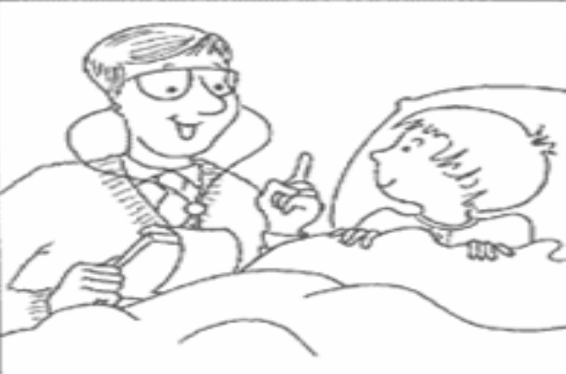 |  | C3
 |  | C4
 |  | C5
 |  | C6
 |  | C7

