Primary school  "Sidi-Ibrahim Zaher"  Sbikha–Kairouan | English exam of the first trimester  2013-2014 | 6th grade
 | Primary school teacher :…………… | Mark  20
.....................................................................Surname- Name

- Reading –comprehension: (8 marks)
Hi! My name is John. I’m twelve. I’m from England. I live in London. It’s a nice and big city. This is my family. This is my father. His name is George. This is my mother. Her name is Amanda. This is my brother Tomy. He’s ten and this my little sister. Her name is Lisa.

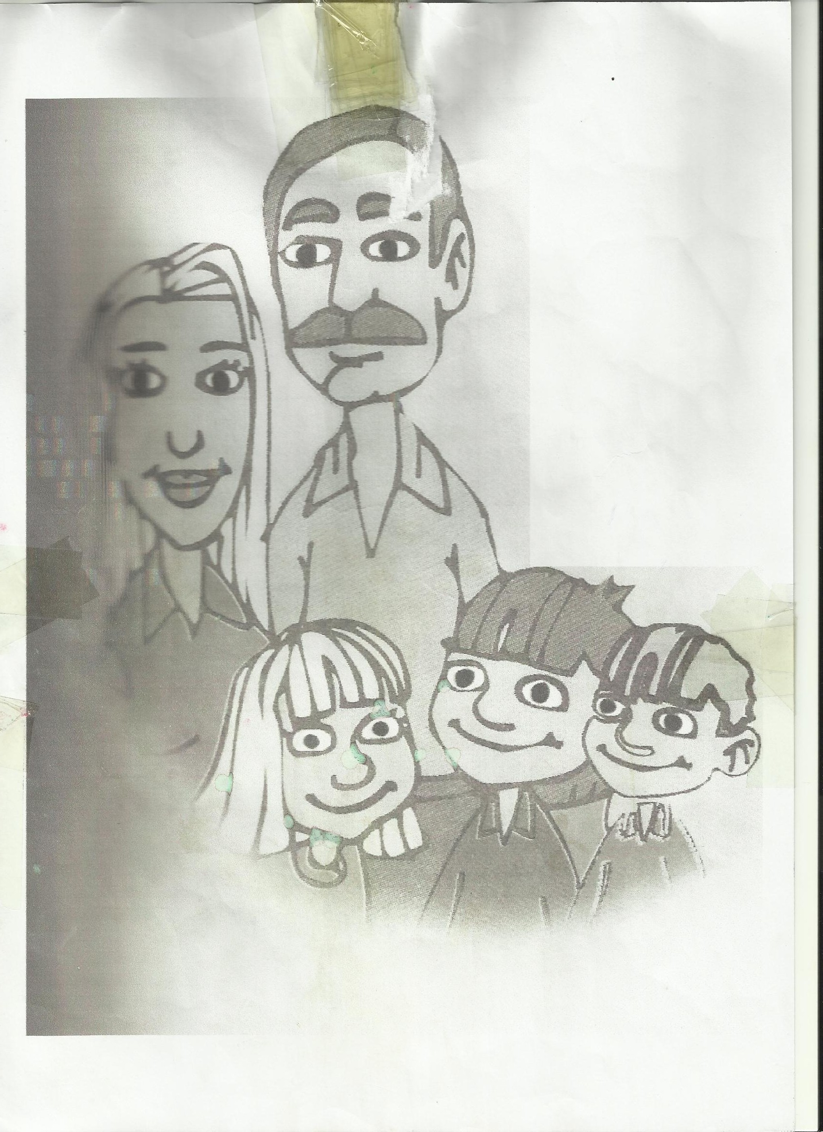

Question nº1: Cross out the wrong answer (3marks)
- John has two brothers.
- John has one brother and one sister.
- Lisa is ten.

Question nº2: Answer the questions (2marks)
- How old is Tomy?
………………………………………………………………………………………………………………………
- Where does John live?
………………………………………………………………………………………………………………………

Question nº3: Complete with words from the text (3marks)
I’m Salah. I’m ………….. Tunisia. I ………….. in Sidi Ibrahim Zaher. It’s…………..and …………… I have a ………….. brother. His ………….. is Sami.

- Language: (6 marks)

Question nº1: Complete with “Who’s”, “What’s”, “How old”, “Where”: (3marks)
Question | Answer
…………… this? | This is my mother.
…………… are you? | I’m twelve.
…………… your name? | My name’s Fatma.
…………… do you live? | I live in Sousse.

Question nº2: Complete with “is”, “are” or “her”: (3marks)
- This ………… my mother. ………… name is Salha. These ………… my brothers. Their names are Sami and Ahmed.

- Writing: (6 marks)
Question nº1: Rewrite the dialogue. Correct the underlined words: (3marks)
- Whose this? - ……………………..………….……………………
- These is my brothers. - …………………..…….……………..……………
- What’s her name? - …………………..…….……………..……………
Question nº2: Make sentences. Reorder these words: (3 marks)

- to / Pleased / you / meet / . /

- ………………………………………………………………………………………………………………

- to / too / Pleased / , / you / meet / . /
- ………………………………………………………………………………………………………………
- do / you / come / Where / ? / from/

- ………………………………………………………………………………………………………………

Primary school El Jhinet  Bouhajla –Kairouan  Primary school teacher:  Yahia Deldoul | English exam  Sixth grade  second trimester | Duration : 50mns  Surname : …......………  Name : …........……..

- Reading –comprehension:
Every day, Loren wakes up early. She washes her face, brushes her teeth then puts on her clothes. She wears her blue jeans, red pullover, pink school uniform and black shoes. Before leaving to school, she catches a glimpse of her new schoolbag. She checks on her books, notebooks and blue, red and green pens. Finally, she goes out to school.
Question nº1: Cross out the wrong answer (1.5marks)
- Loren wakes up early to go to school.
- Loren has got an old schoolbag.
- Loren has got one book in her schoolbag.
Question nº2: Answer the questions (3marks)
- What has Loren got in her schoolbag?
………………………………………………………………………………………………………………………
………………………………………………………………………………………………………………………
- How many pens are there in Loren’s pencil case?
………………………………………………………………………………………………………………………
Question nº3: Tick the right answer (2marks)
 | Blue | Red | pink | Black
Jeans
Pullover
School uniform
Shoes
- Language:

Question nº1: Look at the picture then complete the sentences using “under”, “over”, “in”, “on”: (2marks)

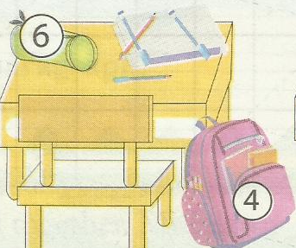
1- The book is ………… the desk.
2- The pencil case is ………… the chair.
3- The schoolbag is ………… the desk.

4- The chair is ………… the desk.
Question nº2: Correct. There are two mistakes in each sentence: (3marks)
1- This are a blue trousers. ……………………..………….……………………
2- These pupil are friend. ………………………..……………..…………… Question nº3: Complete this short dialogue with “is”, “are”, “his” or “her”: (1.5marks)
- How many books ………… there in John’s schoolbag?
- There ………… one book in ………… schoolbag.
- Writing:
Question nº1: Makes out of these words questions then answer them:
(7 marks)
1- colour / is / ? / What /book / your

- ………………………………………………………………………………………………………………

- ………………………………………………………………………………………………………………

2- pupils / How / there / many / your / are / classroom / ? / in

- ………………………………………………………………………………………………………………

- …………………………………………………………………….…………………………………………

Primary school El Jhinet  Bouhajla –Kairouan  Primary school teacher:  Yahia Deldoul | English exam  Sixth grade  Third trimester | Duration : 50mns  Surname : …......………  Name : …........……..
- Reading –comprehension:
We have got a winter, spring and summer holidays. In winter, I go with my family to Tozeur in the south. It’s nice and fine there. In spring holiday, we go to the north, to Ain Drahem. It’s green and beautiful there. In summer, we go to Hammamet. We love swimming and playing on the beach.
Question nº1: Complete the table (1.5marks)
Where? | When? | Why?
Tozeur | …….………………… | …….…………………
…….………………… | …….………………… | Green and beautiful
…….………………… | Summer | …….…………………

Question nº2: Answer the questions (3marks)
- Where is Tozeur?
………………………………………………………………………………………………………………………
- What’s the weather like in Tozeur in winter?
………………………………………………………………………………………………………………………
Question nº3: Complete with words from the text (1.5marks)
Many people go to Ain Drahim in the …………..……….. It’s a …………..……….. place and the people are …………..……….
- Language:
Question nº1: Complete the sentences using “before”, “after”, “in”, “on”, “at” (2marks)
1- January is ………… February.
2- We go to school ………… seven O’clock.
3- ………… Sunday, we do not go to school. It’s a holiday.
4- Monday is ………… Sunday.
Question nº2: Circle the correct words (2marks)
We study many subjects at school. We have Arabic every day except (in / on / at) Friday. We have French (in / on / at) 8 O’clock. English and Maths (am / is / are) my favorite subjects and science (am / is / are) my favorite subject.
Question nº3: Correct these sentences. There are 2 mistakes in each (2marks)
- How is the weather like on Kairouan?
- ………………………………………………………………………………………………………………………
- In Saturday, my father goes to work in 6 O’clock.
- ………………………………………………………………………………………………………………………
- Writing:
Question nº1: Match questions with answers (4marks)
What is the weather like? |  |  | There are twenty.
What time is it? |  |  | It’s on Sunday.
When is your birthday? |  |  | It’s eleven twenty.
How many pupils are there in the classroom? |  |  | It’s sunny.

Question nº2: Reorder the words to make sentences (4marks)
1- twelve / are / in / a year / months / There/ . /

- ………………………………………………………………………………………………………………

2- cold / winter / rainy / is / and / it / . / in /

- ………………………………………………………………………………………………………………

3- is / long / coat / wearing / a / . / black / She/

- ………………………………………………………………………………………………………………
4- birthday / Today / . / my / is /

- ………………………………………………………………………………………………………………

