1st CHILDREN
Student’s Name: _________________________________________________________
Teacher’s Name: _________________________________________________________

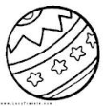
Complete the questions:
- _____________________is that?
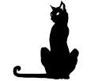
It’s a ball.
- ___________________is the cat? It’s black.

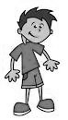
Tom 7

4)________________is this boy? He’s Tom.
- _______________is he?
He’s 7 years old.

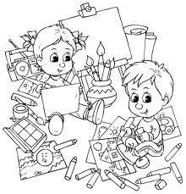
Look at the picture and write YES or NO
1 The children are in the zoo._____
2 Tom is eight years old. _____
3 Tom can draw. ____
4 Lucy is happy. ____
5 Lucy has got black hair. ____
6 She has got big eyes. _____
FAMILY MEMBERS. WRITE
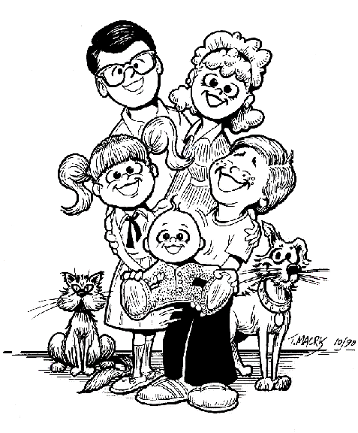
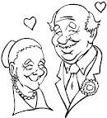

ANSWER ABOUT YOU:
Are you tall? __________________________________________
What can you do? ______________________________________
Have you got a dog? ____________________________________
What’s your favourite animal: _____________________________

Circle the correct option:
I’ m / You’re a farmer.
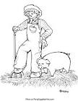
1)

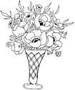
2) How/ Who are you?
I’m fine, thanks.
3)This is/ these are flowers.
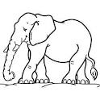
4) I can swim and/ but I can’t ride a horse.
5) Look at the elephant. It’s big/ small.
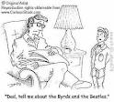

6) Steve is in the dining room/ living room.
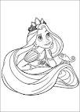

7) Look at his/ her hair. It’s very short/ long.
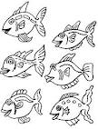
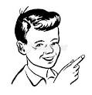
8) We/ they are fish.

PARTS OF THE BODY. WRITE
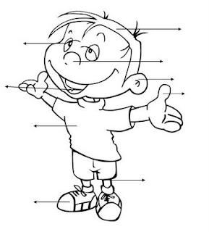

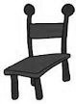
Count and write:
______________________________________________

__________________________________________

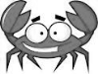
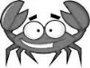
____________________________________________

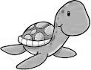

__________________________________
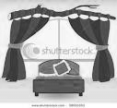
LOOK AT THE PISTURE AND ANSWER:
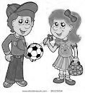
- Where are the children?
_________________________________________
- Are they tall?
__________________________________________
- How old is Paul?
______________________________________
- Can he play football?
______________________________________
- Has Ana got yellow hair?
________________________________________
Write about Spongebob.
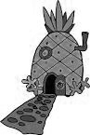
Mention:
Name/ years old/ where? / has got/ can / happy/ sad.



