Success academy mourouj6  TEACHER nawel mathlouthi | English test n°1  December2020 /2021 | Class : 6th form  Name : . . . . . . . . . . . . . .  Surname : . . . . . . . . . . .  Mark : /20

Reading comprehesion
Hello ! my name’s Jane . I’m tweleve years old . I’m a pupil in a primary school. I live with my family in London .My mother is Jennifer and my father is David . Ihave got two ciblings : one brother and one sister. They are pupils too . I have a friend. Her name is Andy. She’s from France.
The questions (8 marks)
1 / Write :True /False (2 marks)
a/Jane is ten years old (………….)
b /Jane has two brothers (…………)
c/Jane’s friend is English (………….)
d/Andy is French (………….)
2/ Complete the sentences with words from the text : (2marks)
Andy is…………… years old. She is a …………. in a …………… school. She has got one ……………… and two brothers .
3/ Answer the following questions : (3marks)
a/How old is Jane ?
………………………………………
b/ Where ‘s Andy from ?
…………………………………..
c/ Is Jane a pupil ?
………………………………………. Tel :23 372 030
4/Circle the right alternative (1marks)
Andy is ( France -French)
Jane is a ( pupil -pupils)
LAnGUAGE (6MARKS )
1/ Put in order to make sentences or questions (1.5 marks)
Tunisian /are/ and/Sami/./Lina/
……………………………………………………………………………………..
Lina/you/from/are/where/ ?/
……………………………………………………………………………….......
American /Lara /is/./
……………………………………………………………………………………
2/ Circle the right answer : (2 marks)
This(is-are—am) my family’s photo. (This –These) are my parents . My(father-mother)is Jessica and my (brother- father) is David .I have got two (sister-brothers).
3/Correct the underlined mistakes(1.5marks)
a/ I’m (eigt )…………… years old .
b/My sister is (too)……….. years old.
c/ I’m (from) ……….. America.
4/ Label the pictures . ( 1marks)
Cut-point-read -colour
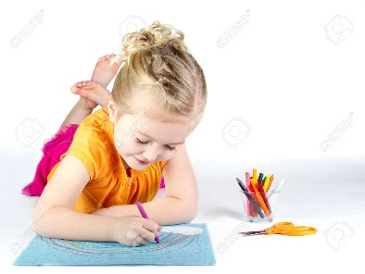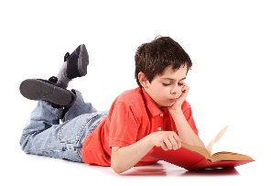
………………….. ……………………… …………………. …………………….

Writing (6 marks)
Write a paragraph about yourself : (name-age-nationality-ciblings-phone number…)
…………………………………………………………………………………………………………
…………………………………………………………………………………………………………………………………………………………………………………………………………………………………………………………………………………………………………………………………………………………………………………………………………………………………………………………………………………………………………………………………………………………………………………………………………………………………………………………………………………………………………………………………………………………………………………………………………………………………………………………………………………………………………………………………………………………………………………………………………………………………………………………………………………………………………………………………………………………………………………………………………………………………………………………………………………………………………………………………………………………………………………………………………………………………………………………………………………………………………………………………………………………………………………………………………………………………………………..

Tel :23 372 030

