6th year | Englich test n2 | Name: . . . . . . . . . . . . . . . . . . . .
Section: Reading:
1/Read the text and answer the following questions
Hello, I'm Peter. I'm 10 years old. I'm fat and short .My hair is black and my eyes are brown. My father Tom is tall and slim. He's 46 years old. His hair is black and white and his eyes are blue. He gets up early every day. He wears his blue jacket, his purple trousers , his new red cap and his black shoes then goes to school by car .He's an English teacher . In his classroom, there are 8 computers, 14 desks and 17 chairs. He loves his job very much.

- A-Tick the right answer
Peter is fat and tall. His hair is black and white.
Tom is Peter's father. He's got blue eyes.
Tom wears a blue jacket, a red cap, purple trousers and black shoes.

B- Colour Tom's clothes:
His jacket  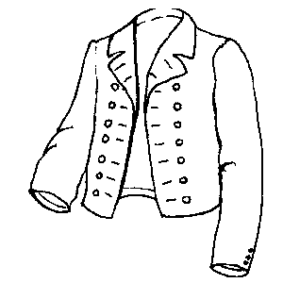 | His trousers  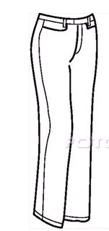
C-Complete The following sentence with the suitable numbers:
There are ……………………… desks, ………………………computers and ………………………chairs in Tom's classroom.

Section 2: Language
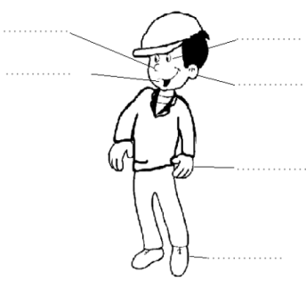
A/ Label the picture after putting in order
the letters.
y-e –e | m-u-t-o-h | r-a-e
s-o-e-n | t-o-f-o | m-a-r

B/ Complete with : This is or These
…………………………….my blue and green pens.
…………………………….her red skirt.
……………………………..white socks.
……………………………….a new pullover.
Section 3: Writing
1/Put the words in order to make sentences:
Wearing –are –What –you – Jane ?
……………………………………………………………………………………….?
Dress –wearing –a red –I am – boots –and –white.
………………………………………………………………………………………………….
Colour -what – cap –your –is - ?
……………………………………………………………………………………………………?
It –pink – and – is –red .
…………………………………………………………………
2/ Read the answer and ask a question:
……………………………………………………………………………………………………..?
There are thirteen desks and five windows in our classroom.

