Farsh Annabi school | Test n°2 | Name&first Name :  ………………………………
Teacher : Miss Dhouha Lahmedi | March2012 | Class : 6th formers:………  N° :…………………….

- Reading comprehension:
. / 7

Hello!
I am writing you this letter to tell you about myself, my family and my activities.
My name is “Minyar” I’m 11 years old. I’m Tunisian and I live in Jerba; a nice and small island in the south of Tunisia.
I’m tall and slim. My eyes are brown, my hear is black.
My father is Ridha, he is 45. Hiba is my mother, she is 36 years old.
I’ve got one sister, her name is Chayma, and one brother, his name is Youssef.
I like my family very much. My best friend is Linda. We are usually together.
We like listening to music and reading books.
I’m a good and very serious student and I like all my teachers because they are kind and helpful. My favourite subjects are maths and English.
I am in the 6th formers in a primary school near to my house.
Today is Saturday. It’s my birthday so I am very glad. I’m wearing a lovely red dress and very beautiful black shoes. Now, it’s six o’clock. All the family is at home; we are eating cake and drinking orange juice.
Please write back soon.
. / 2
- Complete the table with information from the text: {0.5*4}

Name | Age | Nationality | Occupation | Best friend
Minyar | ……… | ………………….. | …………………… | ………………………….
. / 2
- Write true or false : {0.5* 2}
……...
- Minyar likes listening to music.
……..
- Minyar is a bad pupil.
……..
- Minyar has got two sisters.
……...
- Minyar doesn’t like her teachers.
- Complete with words from the text: {0.5*6}
. / 3
- Minyar ………….…..with her family in Jerba the island of dreams in the south of Tunisia.
- Minyar is a very nice girl. Her eyes are……………….
Her …………….is black.
- Her …………….. is forty-five and her mother is………………-….....….
- Minyar and her family are happy, because it’s Minyar’s birthday, they eat ……………and drink orange juice.
. / 9
- Language:
. / 4.5
- Circle the right word: {0.5* 9}
- Ridha is (a - an) student. Now, he (is / are ) at home. He is (does/do/doing) his homework. (On / In) his school, there (is / are) seven classrooms.
- Sabrine is (wears- wearing) a pink skirt, a white shirt and (a / Ǿ ) red shoes.
- (On/ In- At )Sunday, Miriam goes to cinema (on- at - in ) four o’clock( at - in ) the afternoon.
. / 2
- Write “S” = similar or “D” = different: {0.5*4}
- Summer- June ……...
- five- time ……..
- happy- april ………
- red- dress ………
. / 3

- Match : {0.5*6}
- Who is wearing pink | 1-.…. | a. Because it’s very cold.
- What time is it? | 2-…. | b. It’s in the pencil case.
- Where is the bag | 3-…. | c. Rahma is wearing pink, that’s the colour of his pullover.
- What’s she doing? | 4-…. | d. He is reading a story.
- Why is he wearing coat? | 5-…. | e. It’s seven ten.
- What are they wearing? | 6-…. | f. A blue t-shirt, black jeans and white sneakers.

- Writing:
. / 7.5
. / 3
- Match :
- They are going to school. | - …… | a.
- He is playing football. | - …… | b.  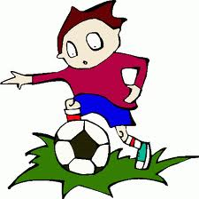
- She is watching T.V. | - …… | 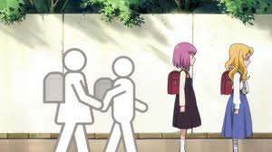
. / 1.5
- Reorder the letters to get words: {0.5*3}
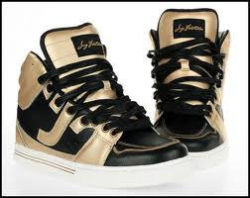 |  | 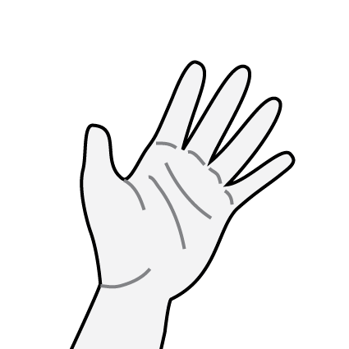
s/k/r/s/n/i/a/e | o/b/o/k/ | a/n/h/d/
a……………………….. | a………………….…… | a……………………..
. / 3
- Reorder the word to get meaning sentences : {1*3}
- have/ I / at/ . / midday/ lunch/ | ……………………………………………….
- . / is /reading/ Adem | ……………………………………………….
- Winter/ it’s/ rainy/ cold/and/In/, /. / | ……………………………………………….
. /24

