School :hay jadid | English exam  2nd Term 2014 | T : B.Abdeljawed Samir
Name : …………………………………………………………………………………………

Text :
Hi ! My name is Kate, I’m 15 years old. Every day I get up early, I wear blue trousers, white socks, brown jacket and black sneakers and I go to school. On Wednesday I have English. I like my English teacher, he’s tall, kind and friendly.
On Sunday, I get up late I have my breakfast with my family, after I go the tennis club to play tennis. My friend Pamela likes reading stories.
- Listen and complete:

Name | Age | friend
……………………….. | …………………….. | ………………………….

- Listen and circle “yes” or “no”:
- Kate is thirteen. Yes / no
- Her friend is Paola. Yes / no
- Mike likes English. Yes / no

- Listen and match:
- Socks - - blue
- Trousers - - black
- Sneakers - - white

- Match the questions with their answers:

Questions | Answers
- How old are you?  - What’s this?  - Who’s this?  - Where’s your brother? | - My father  - Twelve  - Desk  - At school

- Complete:

Monday; ………………….; ……….…………..; Thursday,……………………….
Saturday; Sunday.

- Write the name and colour:

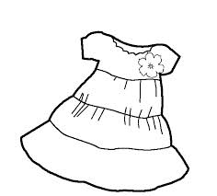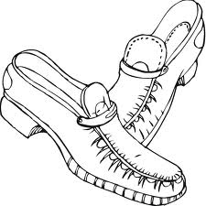

………………………. ……………………………. ………………………………..
( Blue) ( red ) ( brown)

Good luck

