 | End of term English N°3  June 2015 | 6th form  Written test: ……/12  Oral exam: ………/8
Name :…………………………… Class :............. Full Mark : …………/20

The text:
Dear friend,
I’m a pupil at a school in Manchester and I’m sixteen years old. I go to school by bus. I love my town. It has got 2 cinemas, a big park with a zoo next to it. It has got many hotels, cafés, restaurants and stadiums. Tourists love my town and visit it a lot in summer.
I like listening to music and playing tennis. At weekends, I go out with my friends. Sometimes we go to the cinema and sometimes we just go for a walk in the park.
I speak English and French but I don’t like studying maths.
What about you? Please write to me.

- Reading comprehension (4 marks)
- Read and circle “yes” or “no”: (0.25 each)
- Bill likes all sports. Yes - No
- He goes to school on foot. Yes – No
- The zoo is near the park. Yes – No
- All the weekends, Bill stays at home. Yes – No
2)Read and complete the table: (0.25 each)
Name | Age | Occupation | nationality
Bill | ………………………. | …………………….. | ……………………..

3)Read and complete with words from the text: (0.25 each)
- Bill lives in Manchester. It’s a ……………………….. town. Tourists visit it a lot in …………………………… . Bill likes …………………….. to music and playing ……………………….but he doesn’t like studying ……………………..

4)Read and pick up the sentence that describes Bill’s town: ( 1 mark)
……………………………………………………………………………………………………………………………………………………………………………………………………………………………………

II Language (4 marks)
- Circle the correct alternative (0.25 each)
I’m Sandy. I’m (from-on-at) Boston. I (speak-have-go) English and Italian. I’ve got a (new-old-hot) computer and I write all my letters on it but I don’t like (play-playing-plays) basketball. Y favourite pet is (the tiger-the cat-tha apple).

- Fill in the blanks with words from the box (be careful there is an extra word) (0.25 each)
Bedrooms / house / wearing / garden / combing / he / his
Mr. Arnold has got a very large ……………………… . There’s a big living room, a dining room, three …………………….. and two bathrooms. There’s a modern kitchen. There’s also a garage and a nice ……………………. . Mr. Arnold is in the bathroom. ……………..is brushing his teeth. His daughter, Julia, is ………………….her clothes. His son, Peter, is in his bedroom. He’s …………………..his hair.

- Write the opposite of the underlined words: (0.25 each)
- Mary has got a old #.........................pet. it’s a big #...................... cat. She’s very sad #................... because she doesn’t like #...............................animals. today, she gets up late #.......................... to play with her pet.
III Writing (4 marks)
- Look at the pictures, reorder the letters and write the words: (0.25 each)
 | 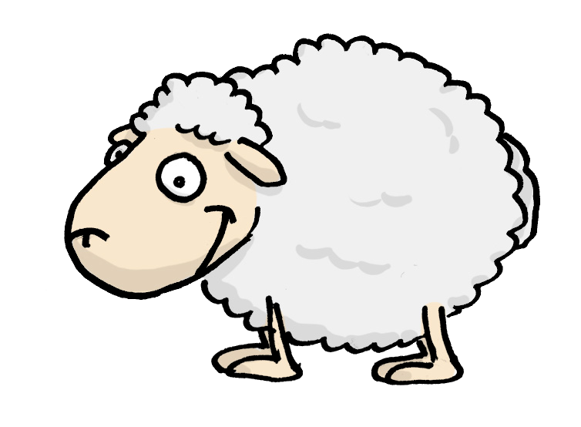
a - b - r - t - i - b | e - e - h - s - p | d - e - r - b - a | r - p - a -e
…………………………… | ………………………. | ………………………….. | ……………………….
- Pu the words in the correct order to get a dialogue: ( 0.5 each)
A : Good morning! ( I - can - you - help)
………………………………………………………………………………………..?
B: Good morning! ( I – one kilo – ‘d like – strawberries – of)
……………………………………………………………………………………….
A : Ok
B : (much – how – it – is)
……………………………………………………………………………………….?
A: 2 dinars.
B: Thank you. Good bye.
A: Good bye.

- Look at the pictures and complete the sentences: (0.5 each)
 |  | 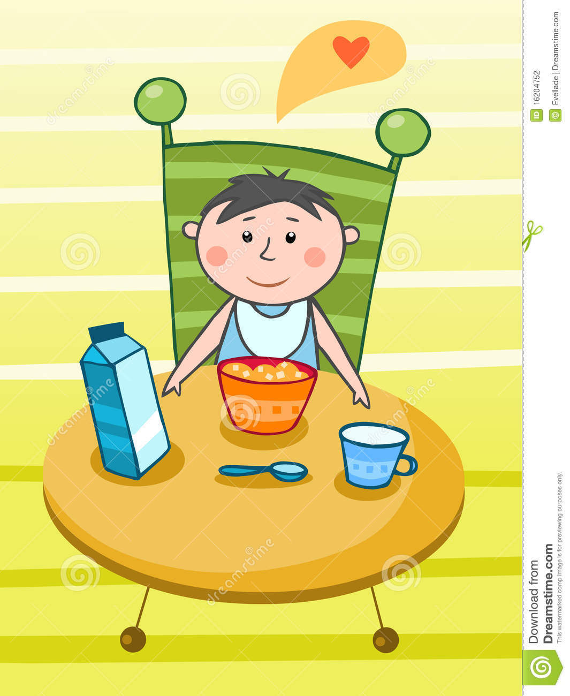
Peter ………………………….at 7:30. | He’s in the bathroom.  He ……………………………….  ……………………………………. | In the kitchen, he…………….  …………………………………………  ………………………………………..

