NAME :…………………..…………………………………..class : 6th form n :……

THIRD TERM ENGLISH TEST
JUNE 2014
Primary School: F.Hached
Mm: Ben Amor Nasra

THE TEXT :

Dear Jennifer,
. I’m very happy to have a pen friend. My name is Tom. I’m English. I’m
an eleven years-old pupil. I live in London. I go to a primary school near my house.

. At school, I study many subjects , maths, history, sciences….. . My favourite subject is English. I’m good at languages. I can speak French,
and of course English but I can’t speak Italian and Chinese. I like drawing but my favourite hobby is listening to music. I also love to play beach ball with my little brother in summer but I hate volleyball.

. On Sundays, I go to a fast food restaurant with my friends. I have chicken, salad and fruit for lunch.

. What about you? Please write me soon and tell me about yourself and your family.

Your friend Tom

- THE QUESTION: (6marks)
Read the text and:
1-Tick ( ) the right answer. (1 mark )

The text is a- an e-mail
b- a postcard
c- a newspaper
2-Write YES or NO. (3 marks )

a-Tom loves languages. …...…..
b-Tom don’t like volleyball. …….….
c- On Sundays, Tom has lunch with his family ………..

3- Correct the underlined statements. ( 2 marks )
a- Tom’s house is near the beach.
……………………………………………………………………………………………………..…………………
b- His favourite hobby is drawing.
………………………………………………………………………………………………………………………

- LANGUAGE : (8marks)
- Complete with words from the box. There is an extra word. (3 marks)
town – small – school – market

I live in a …………………………..………… in the north of Tunisia. It’s ………………….……….
and beautiful. Sunday is ………………………….. day.
- Circle the right word: (3 marks)
On Sundays morning, the children ( going – go – goes ) to the park. In the afternoon they do their ( read – sleep – homework). In the evening, Mr. Robinson takes ( his – he’s – her ) family to their favourite restaurant.
- Write the synonym of the underlined words. ( 2 marks )
Jane: Hello Mary.
Mary: Hello Jane, pleased = ……………. to meet you.
Jane: can you visit me on Saturday? My house is next to = …………… the post office.
Jane: of course I can.
- WRITING: ( 6 marks)
- Reorder the words to make sentences . (3 marks)
- kitchen – mother – is – drinking – My – in – coffee – the – .
……………………………………………………………………………..……………………………………..
- is – of – How – pears – much – a kilo – ?
……………………………………………………………………………………………………….…………...
- today – party – is – birthday – It – my – .
……………………………………………………………………………………………………………………
- Look at the pictures and correct the mistakes. (3 marks )

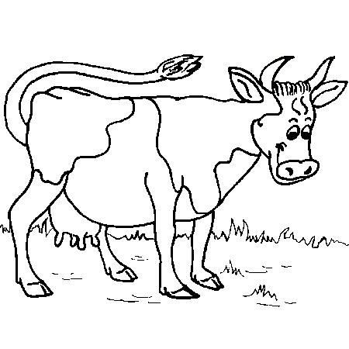
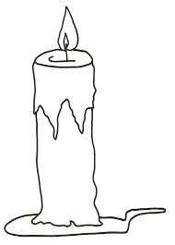

a caw a cundel bred
……………..… ………………..…… …………….…

