الجمهورية التونسية
وزارة التربية
المندوبية الجهوية للتربية بسيدي بوزيد تفقدية المدارس الابتدائية بالرقاب
اختبار تجريبي لتلاميذ السنة السادسة
الاختبار: انقليزية | الحصّة: 45 دقيقة | ماي 2019 | السنة السادسة

The Text :
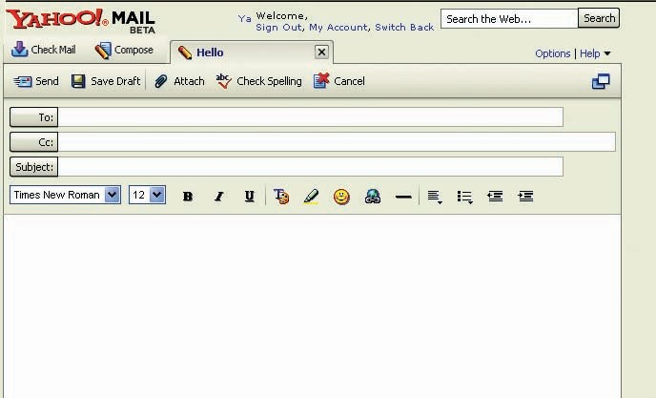

Hi Jane,
I’m a student at a school in London and I’m ten years old. I live with my family. Every day, I go to school by bus. I like listening to music, reading stories and playing
table tennis.
On weekends, I go out with my friends. Sometimes, we go to the cinema. I speak English
and Spanish , but I don’t speak French. My favourite subjects at school are arts and maths
but I don’t like history. What about you? Please write to me.
Love
Max

READING COMPREHENSION QUESTIONS ( 6 marks)
- Who writes the e-mail ? ( 1 mark)
......................................................................................................................

- Tick () the right answer ( 1 mark )
a pupil
Max is ............ a teacher
a cook
- How old is Max? ( 1mark)
....................................................................................................................................

- Correct this false statement. ( 1mark)
Max goes to school on foot.
....................................................................................................................................

- Fill in the blanks with words from the text. ( 2 marks )
Max is from ...................... . He likes table tennis, reading and ............................
He goes out with ................................... . He speaks English and Spanish, but he doesn’t speak ................................. .

LANGUAGE (8 marks)
- Circle the correct word: ( 3marks)
Mary (is / has) in the garden. She is (plays / playing) the guitar. She (likes / don’t like ) music.
- Label the pictures: ( 2marks)
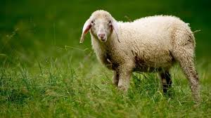
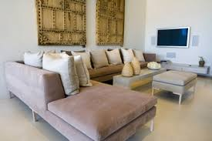
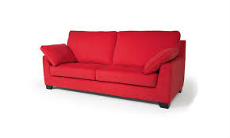
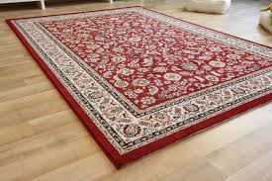

a ................................ a ................ .............. a ............................... a ........................
- Write the opposite of the underlined words: (1 mark)
I live in Bizerte. It’s a small ≠............... town in the south ≠ ............. of Tunisia.

- Match the questions with the answers: (2 marks)
Questions |  | Answers
1) Where’s Mike?  2) When is the birthday party?  3) Who’s in the kitchen?  4) What’s he doing? |  | a- It’s on Sunday.  b- Mum.  c- He’s watching TV.  d- He’s at school.
1 ……. | 2 ……. | 3 …… | 4 …..

WRITING ( 6 marks)
Task 1:
Reorder the words to get meaningful sentences: ( 2 marks)
- she / painting / Does / like / ?
....................................................................................................................................................
- in / I / house / live /a / big / .
....................................................................................................................................................
- rainy / it / Is / today / ?
...................................................................................................................................................
- are / They / writing / in / the living room / e-mails/ .
...................................................................................................................................................

Task 2:
Your new friend on Facebook asks you to introduce yourself. Write an E-mail to tell him about your name, age, nationality, daily activities, hobbies, … (4marks)

- Turn to page 4

Hi

Hi........... ;
.......................................................................
......................................................................
Evreryday;.............................................................
.......................................................................
......................................................................
I like.........................................................................
..................................................................................
.................................................................................
Love
................

Good Luck !

Task 2/writing evaluation criteria:
Adherence to task and content adequacy | 1 mark
Lexical appropriacy and grammar accuracy | 2 marks
Mechanical accuracy (punctuation, capitalization , and spelling) | 1 mark

