‘Used to’ , ‘Would’ , ‘Be used to’ , ‘Get used to’ :
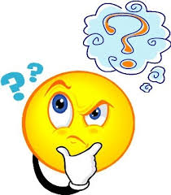

Any Differences?

‘Used to + infinitive’ and ‘be/get used to + -ing/noun’ look similar but they have very different uses.

Would
We can use would to talk about repeated past actions that don't happen any more.
Every Saturday I would go on a long bike ride.
My dad would read me amazing stories every night at bedtime.
would for past habits is almost like used to . It is slightly more formal than used to. It is often used in stories. There is no negative or question form of would for past habits. Note that we can't usually use would to talk about past states.

used to
Subject + used to + bare infinitive
We use used to + infinitive to talk about a past situation that is no longer true. It tells us that there was a repeated action or state in the past which has now changed.
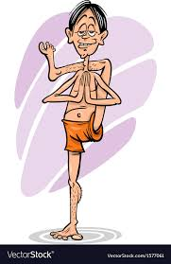
She used to be a long-distance runner when she was younger.
I didn't use to sleep very well, but then I started doing yoga and it really helps.
Did you use to come here as a child?

be used to
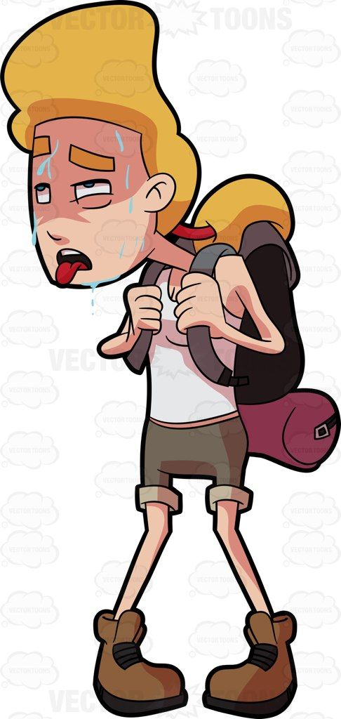
Subject + be used to + noun/gerund
Be used to means 'be familiar with' or 'be accustomed to'.
She's used to the city now and doesn't get lost any more.
He wasn't used to walking so much and his legs hurt after the hike.
I'm a teacher so I'm used to speaking in public.

get used to
Subject + get used to + noun/gerund
We use get used to to talk about the process of becoming familiar with something.
I'm finding this new job hard but I'm sure I'll get used to it soon.
It took my mother years to get used to living in London after moving from Pakistan.
I'm getting used to the noise now. I found it really stressful when I first moved in.

Be used to and get used to are followed by a noun, pronoun or the -ing form of a verb, and can be used about the past, present or future.

Choose the correct option to complete the sentences.
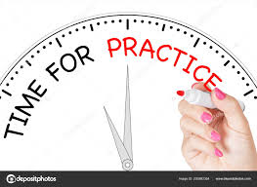
I always hated the cold weather but I _____________ it when I lived in Russia.

get used to
got used to
used to
We ____________ much positive feedback about our old product, but the new formula is really successful.

didn't use to get
weren't used to get
didn't use to getting
I work from home so I _____________________ people around me all day.

'm not used to have
'm used to not having
used to having
I heard Eliza got promoted! ___________________ her as your boss yet?

Are you used to having
Did you used to have
Are you used to have
You've stopped hiking? But why? You ____________________ all the time.

used to go
got used to go
used to going
I've been a nurse for two years but I don't know if I __________________ night shifts.

'll ever used to work
'll get used to work
'll ever get used to working
Even though I loved my old job, I __________________ the long hours.

couldn't be used to
couldn't get used to
couldn't use to
I ___________________ the guitar but I don't have time now.

got used to playing
used to playing
used to play
I ___________________ a really sporty person.

would be
used to be
I ____________________ sugar in my tea because it wasn't on my diet plan.
Haut du formulaire
didn't use to have
wouldn't have
Bas du formulaire

https://learnenglish.britishcouncil.org/grammar/intermediate-to-upper-intermediate/used-to-infinitive-and-be-or-get-used-to-ing
https://learnenglish.britishcouncil.org/grammar/intermediate-to-upper-intermediate/past-habits-used-to-would-and-the-past-simple

